**Bukti Screenshot Persetujuan Poster TA – 220180494**

**Dosen Pembimbing**

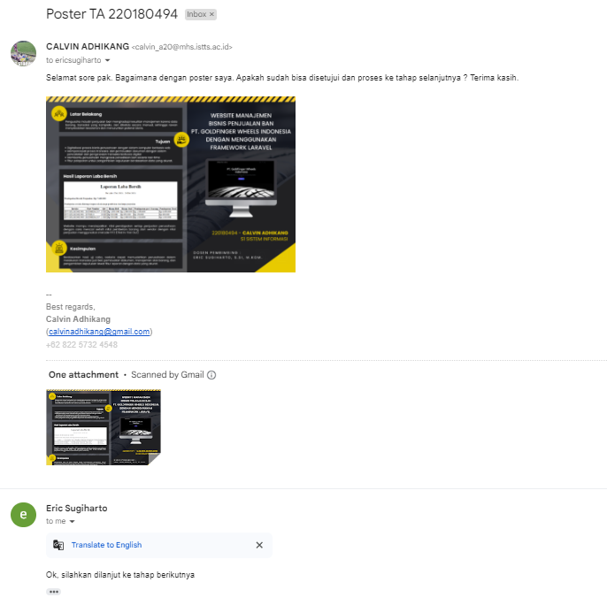

**Dosen ECC**

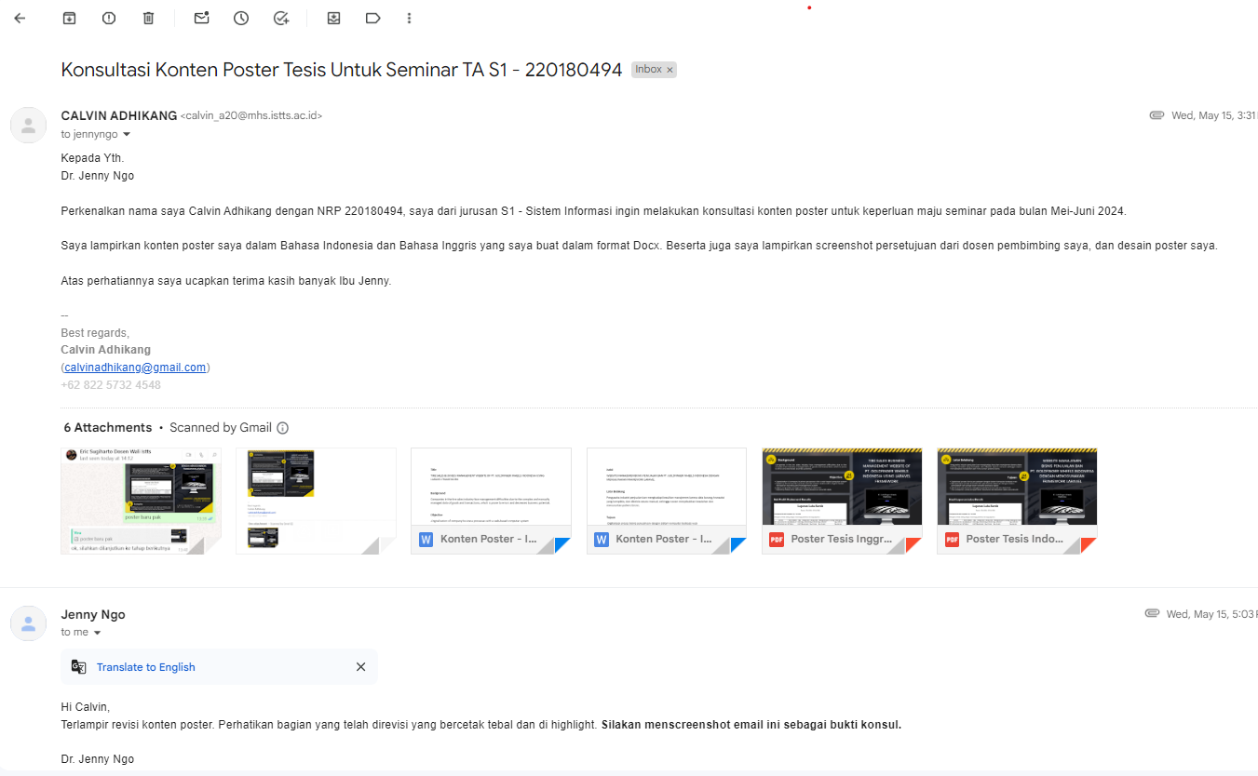

**Dosen DKV**